一、程序代码

#include<iostream>

using namespace std;

class Complex {

double real;

double imag;

public:

Complex(double r = 0, double i = 0)

{

real = r; imag = i;

}

void print();

friend Complex operator\*(Complex co1, Complex co2);

};

Complex operator\*(Complex co1, Complex co2)

{

Complex temp;

temp.real = co1.real \* co2.real - co1.imag \* co2.imag;

temp.imag = co1.real \* co2.imag + co1.imag \* co2.real;

return temp;

}

void Complex::print()

{

cout << "相乘后的积为：" << real << "+" << imag << "i" << endl;

}

int main()

{

float a, b, c, d;

cout << "请输入虚数a的实部和虚部：" << endl;

cin >> a >> b;

cout << "请输入虚数a的实部和虚部：" << endl;

cin >> c >> d;

Complex com1(a, b), com2(c, d), total1;

total1 = com1 \* com2;

total1.print();

return 0;

}二、程序结果

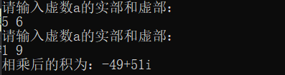

三、感想心得

构造函数和析构函数无法被继承。

Copyright ©2021-2099 ShuoWang. All rights reserved